Document title: Digital Innovation in Modern Business

Understanding Digital Transformation
Digital transformation has become a critical imperative for organizations across all industries. This comprehensive process involves integrating digital technology into all areas of a business, fundamentally changing how companies operate and deliver value to customers. It requires cultural change that challenges organizations to continually experiment, fail fast, and learn from failures.
The transformation encompasses more than just adopting new technologies; it represents a paradigm shift in how businesses approach problem-solving, customer engagement, and operational efficiency. Companies that successfully navigate this transformation often see improved customer experiences, streamlined operations, and enhanced competitive advantages in their respective markets.

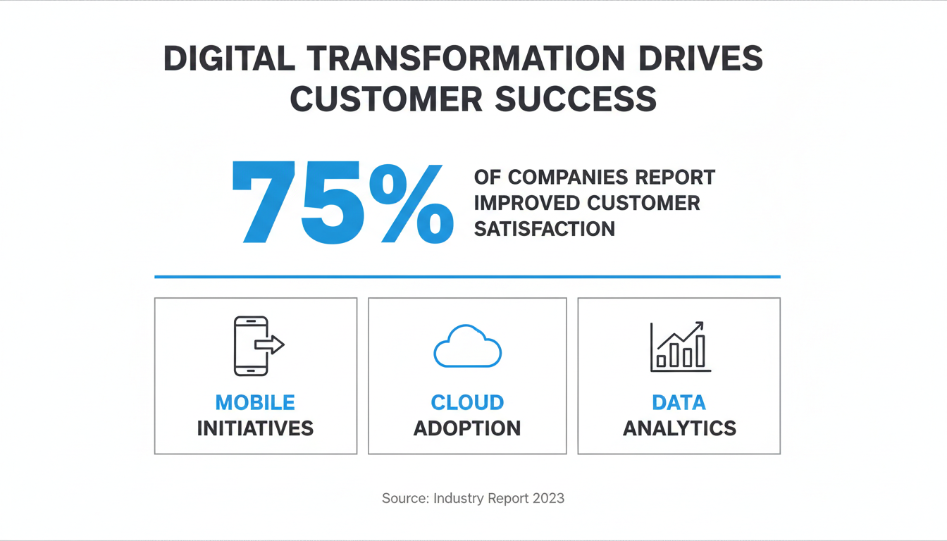

Learn more: Digital transformation insights

The Role of AI
AI (Artificial Intelligence) has emerged as one of the most transformative technologies of our time, revolutionizing how businesses process information, make decisions, and interact with customers. From machine learning algorithms that predict consumer behavior to natural language processing systems that enhance customer service, AI applications are becoming increasingly sophisticated and accessible.
Organizations are leveraging AI to automate routine tasks, analyze vast amounts of data for actionable insights, and create personalized experiences for their users. The technology enables companies to operate more efficiently while providing enhanced services that were previously impossible or economically unfeasible.



Explore AI solutions: https://www.example.com/services/artificial-intelligence

Sustainable Technology Practices
As environmental concerns continue to shape business priorities, sustainable technology practices have become essential for long-term success and corporate responsibility.

"La technologie durable n'est pas seulement une responsabilité environnementale, mais aussi une opportunité stratégique pour les entreprises qui cherchent à innover et à créer de la valeur à long terme." - Marie Dubois, Sustainable Development Expert

Digital Marketing Analytics Overview
Digital marketing has evolved significantly with the advent of sophisticated analytics tools and data-driven strategies. Understanding key metrics and performance indicators is crucial for optimizing marketing campaigns and achieving business objectives.

Metric | Description | Target Range | Frequency
Conversion Rate | Percentage of visitors who complete desired action | 2-5% | Daily
Click-Through Rate | Percentage of users who click on specific link or ad | 1-3% | Daily
Cost Per Acquisition | Amount spent to acquire one new customer | $10-50 | Weekly

